Resale and LWS Disconnects, Suspends, and Restores

Job Aid

Contents
Job Aid Overview 2
Disconnect Orders 2
Overview 2
Creating the Disconnect Order 2
Suspend and Restore Orders 6
Overview 6
Legacy CenturyLink (LC) Suspension and Restoral 6
LC Suspend 6
LC Restore 8
Legacy Qwest (LQ) Suspension and Restoral 9
LQ Suspend and Restore 9

Job Aid Overview
Resale and LWS services may be disconnected, suspended, or restored once the install has completed. This job aid will cover those requests for both the Legacy CenturyLink (LC) region and the Legacy Qwest (LQ) region.

Disconnect Orders

Overview
WBSA services will be disconnected by issuing a Disconnect LSR in EASE. While all EASE Resale orders are similar, there are some differences from the New Install when issuing a Disconnect. This document discusses some of those differences. Please note that EASE order for Legacy CenturyLink and Legacy Qwest may have different entries for the same field. They will be noted as LC (CenturyLink) and LQ (Qwest).

Creating the Disconnect Order
The table below provides high level steps for issuing a Disconnect LSR.
Step | Action
1 | Create the LSR. Hover over ORDER and click New.  - Select the Managed ESP, if necessary. It will be the ESP that includes access to LC region OCN or LQ region RSID.  - Enter the order number in the Order Number field.  - Select the OCN.  - Select the Service type:  - EB-Resale – for Resale service  - MB-Combined loop and unbundled loop switching – for LWS service  - Select D-Disconnection in the Activity field.  - Click Initiate.

Creating the Disconnect Order, cont.
Step | Action
2 | Populate the LSR form.  LSR Form Entry  LSR Admin Section:  - Enter 1 in LOCQTY field.  - LQ only: Enter the Account Number in the AN field, ex: 111-222-3333-444  - Select E (LC) or C (LQ) in RTR.  - Enter CCNA – CCNA = ACNA for CenturyLink region or RSID for Qwest region  Authorization section:  - Enter TOS:  - LC region: 1BF- for Business, 2BF- for Residence  - LQ region: 1BF for Business, 2BF for Residence  - Select DDD (Desired Due Date)  Contact section:  - Enter name of person creating LSR in IMPCON field (to the right of the screen)  - Enter TN of person creating the LSR in IMPCON TEL NO field.  Remarks Info section:  Enter remarks pertinent to the request in REMARKS1. (Example: Disconnect 1 TN)

Creating the Disconnect Order, cont.
Step | Action
3 | Populate the EU form.  LOC ACCESS section:  - Enter 1 in LOCNUM field.  - Enter name of the end-user in NAME field, must be 2 words, ex: McDonald’s Restaurant.  LOC ACCESS INFO section:  - Enter local contact person in LCON.  - Enter local contact person telephone number in TEL NO.  SVC ADDR GRP section:  - Populate the service address:  - SANO – Svc Address Number (required)  - SASD – Svc Address St Direction Prefix (required if part of address)  - SASN – Svc Address Street Name (required)  - SATH – Svc Address Street Type (required)  - SASS – Svc Address St Dir Suffix (required if part of address)  - CITY – Required  - STATE – Two Alpha characters (required)  - ZIP  - LD/LV – Supplemental information such as unit, bldg., etc. (required if part of address)
4 | Click on the RS form and populate as detailed below.  RS ADMIN section:  - Populate the RSQTY field with the number of TNs being disconnected. Example: 0001, 0002, etc.

Creating the Disconnect Order, cont.
Step | Action
4, cont | - Populate the telephone number(s) for the service being disconnected in the TNS field(s), ex 1234567890. If disconnecting more than 1 TN, add additional sections using the Add link in the RS_SVC_Det section:  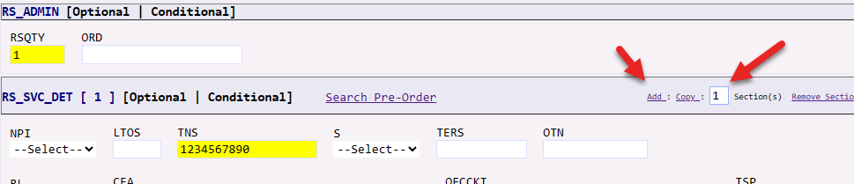  SVC DET GRP section:  - Enter 01 in LOCNUM field for each TN.  - Enter 01 in LNUM field for each TN.  - Enter D in LNA field for each TN.
5 | Save, Validate, and Submit the order.  NOTE 1: If the screen below displays, populate as shown and click SUBMIT.  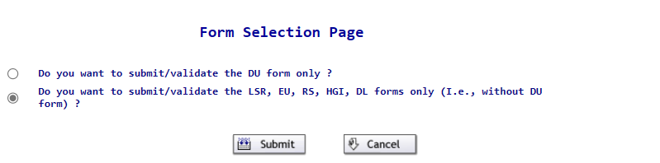  NOTE 2: If the error SC IS Required displays, populate the SC field with the CCNA used on the order.

Suspend and Restore Orders

Overview
Resale and LWS service allows for temporary service suspension and subsequent restoral. Since the process is different depending on region, this job aid will be presented in two parts: Legacy CenturyLink Suspension and Restoral and Legacy Qwest Suspension and Restoral. This job aid does not cover Seasonal Suspension.
Suspension must be issued prior to Restoral.

Legacy CenturyLink (LC) Suspension and Restoral

LC Suspend
The table below provides steps for issuing a Suspend LSR in the LC region.
Step | Action
1 | Create the LSR using the same steps found in the Disconnect section above.  - Use ACTIVITY S - Suspend instead of D
2 | Populate the LSR and EU forms using the same steps found in the sections above.
3 | Click on the RS form.  RS ADMIN section:  - Enter 0001 in RSQTY field.

LC Suspend, cont
Step | Action
3, cont | - Populate the telephone number for the service being suspended in the TNS field.  SVC DET GRP section:  - Enter 01 in LOCNUM field.  - Enter 01 in LNUM field.  - Enter S in LNA field.  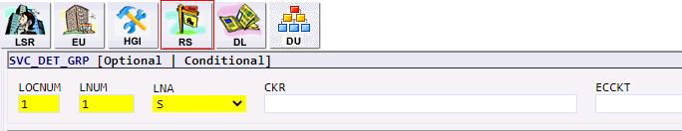
4 | Save, Validate, and Submit the order.  NOTE 1: If the screen below displays, populate as shown and click SUBMIT.  NOTE 2: If the error SC IS Required displays, populate the SC field with the CCNA used on the order.

LC Restore
The table below provides steps for issuing a Restore LSR in the LC region.
Step | Action
1 | Create the LSR using the same steps found in the Disconnect section above.  - Use ACTIVITY B – Restore instead of D
2 | Populate the LSR and EU forms of the LSR using the same steps found in the Disconnect sections above.
3 | - Click on the RS form.  - RS ADMIN section:  - Enter 0001 in RSQTY field.  - Populate the telephone number for the service being suspended in the TNS field.  - SVC DET GRP section:  - Enter 01 in LOCNUM field.  - Enter 01 in LNUM field.  - Enter B in LNA field.  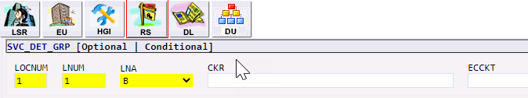

LC Restore, cont
Step | Action
4 | Save, Validate, and Submit the order.  NOTE 1: If the screen below displays, populate as shown and click SUBMIT.  NOTE 2: If the error SC IS Required displays, populate the SC field with the CCNA used on the order.

Legacy Qwest (LQ) Suspension and Restoral

LQ Suspend and Restore
The table below provides steps for issuing a Suspend or Restore LSR in the LQ region.
Step | Action
1 | Create the LSR using the same steps found in the Disconnect sections above.  - Use ACTIVITY C – Change an existing account instead of D
2 | Populate the LSR and EU forms of the LSR using the same steps found in the Disconnect sections above but with the exception below.  - Populate the AN field with the account number. This should resemble a telephone number, ex: 999-999-9999-999  - Populate Remarks1 field with SUSPEND SERVICE

LQ Suspend and Restore, cont.
Step | Action
3 | Click on the RS form.  RS ADMIN section:  - Enter 0001 in RSQTY field.  - Populate the telephone number for the service being suspended or restored in the TNS field. This should be the same number used in the AN field without the final 3 digits.  SVC DET GRP section:  - Enter 01 in LOCNUM field.  - Enter 01 in LNUM field.  - Enter C in LNA field.  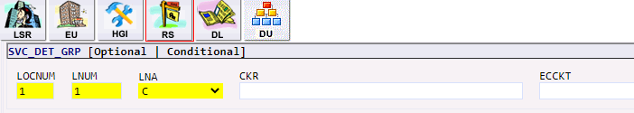

LQ Suspend and Restore, cont.
Step | Action
3, cont | FEATURE GRP Section:  - Enter 2 in Section(s).  - Click Add.  Result: There are now three Feature fields available to be populated.  FEATURE GRP [1] Section:  - Enter O in FA field.  - Enter GFB or GFR in FEATURE field.  FEATURE GRP [2] Section:  - Enter I in FA field.  Enter GFB or GFR in FEATURE field.  FEATURE GRP [3] Section:  If… Then…  Suspend FA = N FEATURE = SCG4X  Restore FA = D FEATURE = SCG4X  Note: SCG4X is the Suspend USOC, so adding it suspends the service, and removing it restores the service.

LQ Suspend and Restore, cont.
Step | Action
4 | Save, Validate, and Submit the order.  NOTE 1: If the screen below displays, populate as shown and click SUBMIT.  NOTE 2: If the error SC IS Required displays, populate the SC field with the CCNA used on the order.

